

**A BRONX TALE**

**E.C. - Neighborhood Map Exercise**

1. 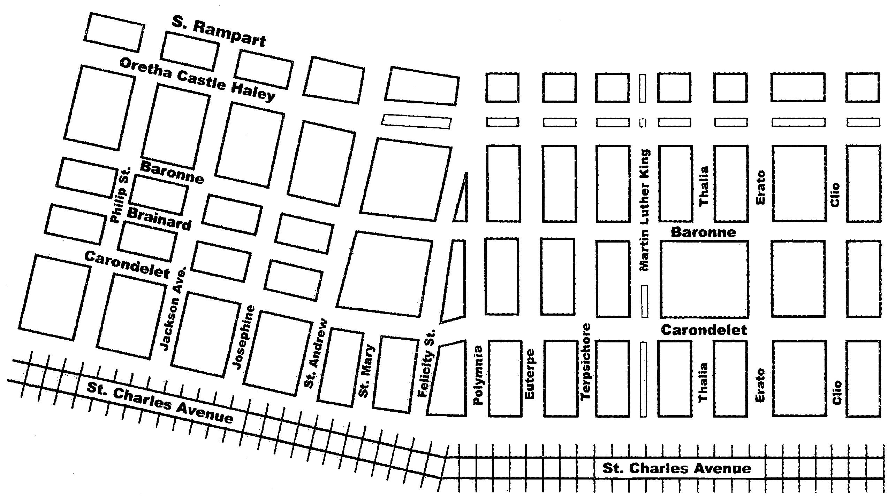Draw a map of your childhood neighborhood. Use any suitable style.

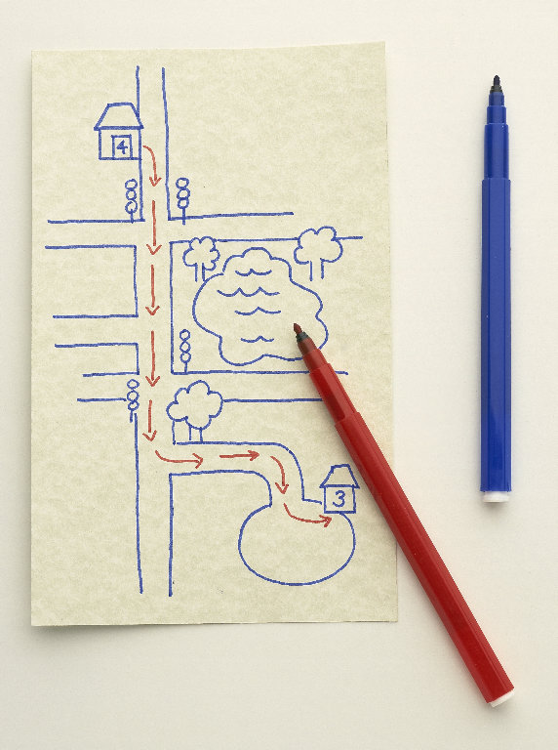

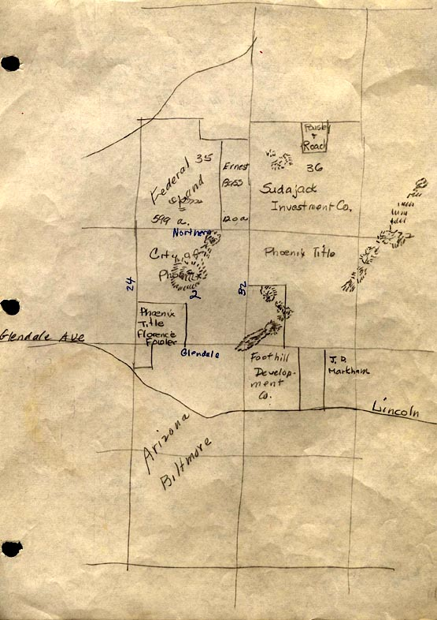

**X**

**X**

**X**

1. Identify important locations on your map with names or labels.

**X**

**X**

1. Pinpoint 5-10 places where things have happened. Put an “X” on those places.

**X**

1. Write about 3-5 of your “X”s in paragraph form.

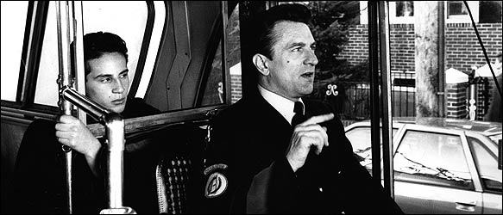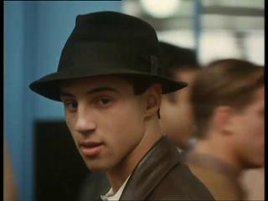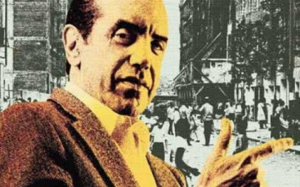

**A BRONX TALE**

[Robert De Niro](http://www.fandango.com/robertdeniro/filmography/p17593) - Lorenzo Anello

[Chazz Palminteri](http://www.fandango.com/chazzpalminteri/filmography/p54860) - Sonny

[Steve Pendleton](http://www.fandango.com/stevependleton/filmography/p55899) - Satan's Messenger

[Tommy A. Ford](http://www.fandango.com/tommya.ford/filmography/p24270) - Phil the Peddler

[Joseph D'Onofrio](http://www.fandango.com/josephdonofrio/filmography/p16485) - Slick age 17

[Elizabeth Abassi](http://www.fandango.com/elizabethabassi/filmography/p55) - Lady in Window

[Ida Bemardini](http://www.fandango.com/idabemardini/filmography/p5789) - Fish Store Customer

[Garry Blackwood](http://www.fandango.com/garryblackwood/filmography/p6494) - Chez Bippy Customer

[Nicky Blair](http://www.fandango.com/nickyblair/filmography/p6536) - Jerry

[Dave Salerno](http://www.fandango.com/davesalerno/filmography/p609456) - Frankie Coffecake

[Chad Dowdell](http://www.fandango.com/chaddowdell/filmography/p219482) - Joey's Friend (uncredited)

[Domenick Lombardozzi](http://www.fandango.com/domenicklombardozzi/filmography/p223353) - Nicky Zero

[Lillo Brancato Jr.](http://www.fandango.com/lillobrancatojr./filmography/p8048) - Calogero Anello (Age 17)

[Francis Capra](http://www.fandango.com/franciscapra/filmography/p10756) - Calogero Anello (Age 9)

[Taral Hicks](http://www.fandango.com/taralhicks/filmography/p209016) - Jane

[Kathrine Narducci](http://www.fandango.com/kathrinenarducci/filmography/p210333) - Rosina Anello

[Clem Caserta](http://www.fandango.com/clemcaserta/filmography/p11552) - Jimmy Whispers

[Alfred Sauchelli, Jr.](http://www.fandango.com/alfredsauchelli,jr./filmography/p270902) - Bobby Bars

[Joe Pesci](http://www.fandango.com/joepesci/filmography/p56237) - Carmine

[Paul Perri](http://www.fandango.com/paulperri/filmography/p106147) - Crazy Mario (Age 9)

[Mitch Kolpan](http://www.fandango.com/mitchkolpan/filmography/p187019) - Detective Belsik

[Patrick Borriello](http://www.fandango.com/patrickborriello/filmography/p198630) - Slick (Age 9)

[Joe Black](http://www.fandango.com/joeblack/filmography/p207115) - Murdered Man